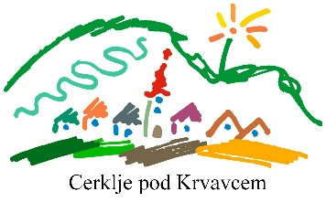

FOR ALL THE BIRD LOVERS AND WATCHERS

As for every Slovenian ornithologist, bird observer and researcher, it also applies to you that:

- Before all other interests, represent the interests of nature protection and bird
- During your work and also otherwise, do not disturb the birds unnecessarily and do not harm them!
- Do not endanger other living beings and nature
- Do not take birds from the wild and do not keep them in captivity.
- Be considerate when photographing birds and nature. Endangered species are not photographed in the nest!
- Conscientiously record all observations and make sure that the data in the notes does not become old.
- Cooperate with colleagues, help them with their work and take care of good relationships with them.

According to the code of Slovenian ornithologists (adopted at the annual meeting of the DOPPS in Maribor, 21 March 1992)

There is only one nature
LET'S PROTECT IT!

